Learning Journal Unit 5

Department of Computer Science, UoPeople

BUS 1101-01 Principles of Business Management - AY2024-T1

Instructor Chinu Singla

**Saturday, 7 September 2023**

**1. Identification of Input and Output Signals**

Input Signal: The switch (S) can exist in two states:

S = 1 when the switch is closed (ON).

S = 0 when the switch is open (OFF).

Output Signal: The light bulb (B) also has two possible states:

B = 1 when the bulb is on.

B = 0 when the bulb is off.

**2. Application of Boolean Algebra Laws**

The behavior of the circuit can be represented using Boolean algebra. The light bulb (B) will be on (B = 1) when the switch (S) is closed (S = 1), and the bulb will be off (B = 0) when the switch is open (S = 0). This relationship can be described by the Boolean expression:

B = S

This indicates that the state of the light bulb is directly determined by the state of the switch, meaning they are in a direct relationship.

**3. Depiction of the Final Circuit**

The circuit design is straightforward, as indicated by the Boolean expression B = S. The input signal (switch) is passed directly to the output (light bulb) without the need for any additional logic gates.

In digital logic terms, this can be achieved with a single buffer gate, which ensures that the input is passed directly to the output without alteration. However, in practical terms, the circuit could be implemented without any logic gates at all, by simply connecting the switch and the light bulb directly.

In this scenario, the buffer gate acts like a wire, transmitting the input signal directly to the output. To minimize the use of logic gates, a direct connection or a single buffer is the most efficient solution. This is why, in practice, a direct connection without any logic gates is often the optimal choice.

I used online available logic gate emulator for this demo. [https://logic.ly/demo/]

*When the switch is open (OFF), the bulb remains off.*

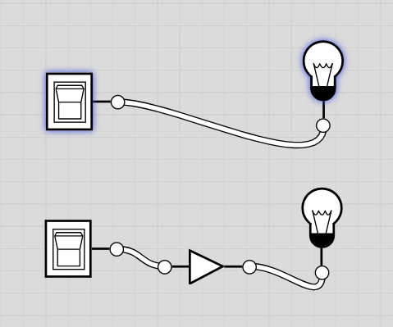

*When the switch is closed (ON), the bulb turns on.*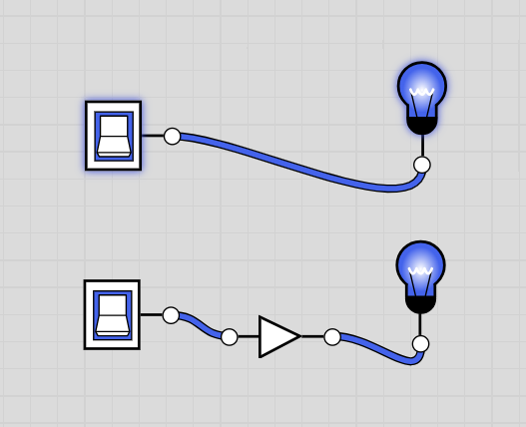

In this scenario, the buffer gate acts like a wire, transmitting the input signal directly to the output. To minimize the use of logic gates, a direct connection or a single buffer is the most efficient solution. This is why, in practice, a direct connection without any logic gates is often the optimal choice.